**Lesson 7 Demo 2**

**Run new Freestyle Jenkins Job on slave**

**Objective:** Configure a Freestyle Jenkins job to execute build on slave.

**Tools required:** Jenkins, slave VM

**Pre-requisites:** You need to have a Jenkins up and running and new slave VM.

Steps to be followed:

1. Log in to Jenkins CI tool and configure freestyle job to run with slave machine instead of master

**Step 1: Log in to Jenkins CI tool and configure freestyle job to run with slave machine instead of master**

1. First login to Jenkins and Navigate to Free Style job and select desired job.
2. Then click on Configure option to configure Jenkins job and execute builds on slave machines.

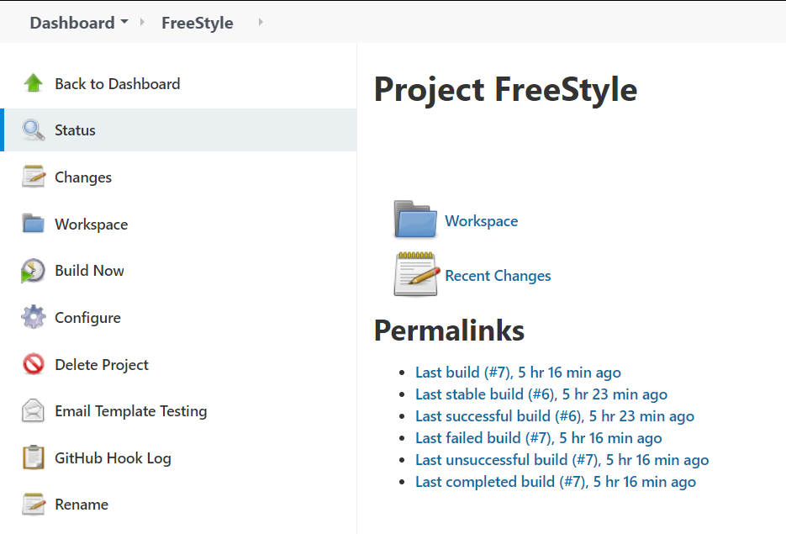

1. Next navigate to General tab and scroll down to configuration named as Restrict where this project can be run.

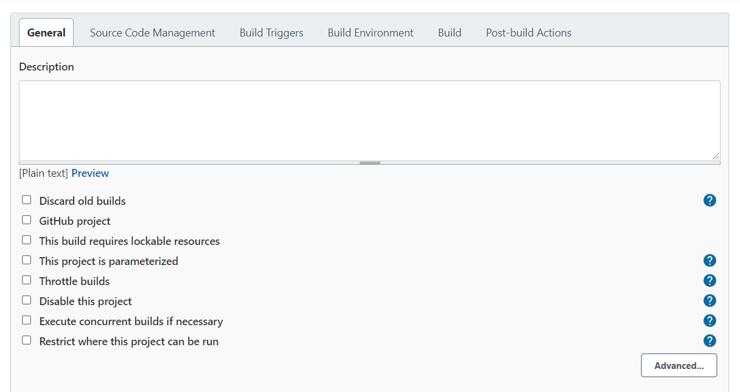

1. Next provide label name which will define slave machine on which we want to trigger this build.

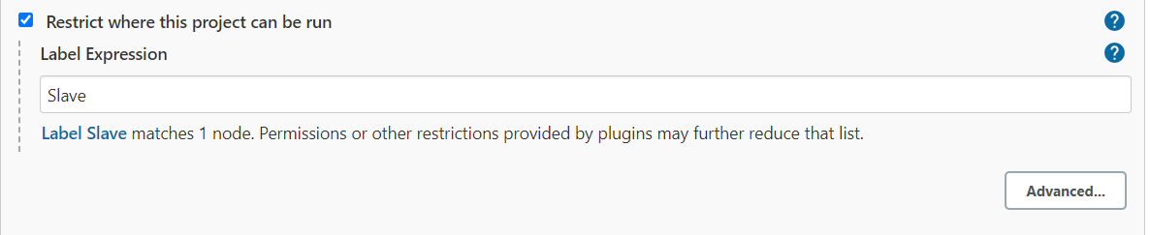

1. Once label is configured trigger fresh build to understand if new build is getting triggered on remote slave machine or not.

